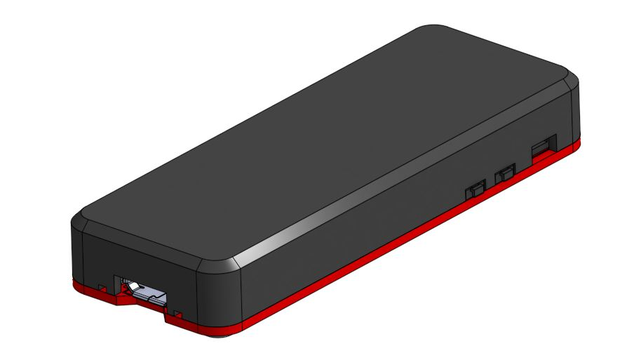

v^SPEED Vario mini

User Manual

Braedin Butler

v^SPEED VARIO

vspeedvario@gmail.com

**Contents:**

Getting Started with Arduino IDE...................................................................................................2

Using your v^SPEED mini................................................................................................................2

* Adjust Custom Settings
* Bluetooth Operation

Firmware Updates..........................................................................................................................3

**Getting Started with Arduino IDE:**

Arduino IDE is a widely used Integrated Development Environment. It is used to compile and execute written code.

Follow these steps to be able to use your v^SPEED mini:

* Install Arduino IDE
* Tools -> Boards Manager -> Search for: Arduino SAMD Boards -> Install
* Tools -> Boards Manager -> Search for: Adafruit SAMD Boards -> Install
* Tools -> Board -> Select: Adafruit Feather M0
* Connect your v^SPEED mini to your computer
* Tools -> Port -> Select any port for now
* Sketch -> Upload

**Using your v^SPEED mini:**

**Adjust Custom Settings –**

* Open the “vSpeed_mini.ino” file
* Open the “DEFAULT_SETTINGS.h” tab
* Change any of the values according to your preference
* Tools -> Board -> Select: Adafruit Feather M0
* Connect your v^SPEED mini to your computer
* Tools -> Port -> Select the correct port
* Sketch -> Upload

**Bluetooth Operation –**

**Android Users:**

* Download the v^SPEED Vario app from Google Play Store.

**iPhone Users:**

* Download Flyskyhy from the App Store.
* When choosing your external vario model, select Skydrop

**Firmware Updates:**

* For the most up-to-date source code for your v^SPEED mini, download and extract the files in the GitHub repository: (<https://github.com/glydrfreak/vSpeedVario-mini>) and replace the existing files in your “vSpeed_mini” folder.
* You may want to keep your existing “DEFAULT_SETTINGS.h” file if you have made changes to it.
* To see the most recent date that your existing code was updated, see the first line of code in “vSpeed_mini.ino”.
* a changeLog.txt is provided in the “vSpeed_mini” folder.